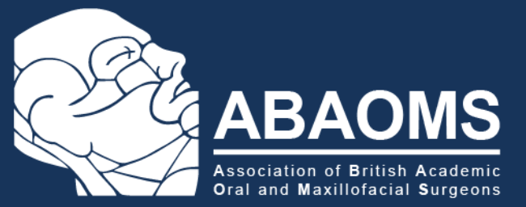

ANNUAL SCIENTIFIC CONFERENCE 2024
27th – 29th November 2024

Bristol Dental School & Future Inn Bristol

Wednesday 27th November

Bristol Dental School, 1 Trinity Walk, Avon St, Bristol BS2 0PT

Agenda | Time
Trainees Meeting and Study Day  Bristol Dental School Café, Ground Floor | 09:00 | 17:00
AGM Committee Meeting  Bristol Dental School room G.42, Ground Floor | 14:00 | 15:00
Education Committee Meeting  Bristol Dental School room G.42, Ground Floor | 15:00 | 17:00
Tour of the new Bristol Dental School | 17:00 | 18:00

Thursday 28th November
Future Inn Bristol Cabot Circus, Bond St, Bristol BS1 3EN

Agenda | Time
Welcome & Conference Opening  Mr Josiah Eyeson, ABAOMS President-elect | 09:00 | 09.15
The silent pandemic – should OMFS be talking antimicrobial resistance or stewardship?  Professor Andrew Smith  Professor of Clinical Bacteriology, Glasgow Dental School | 09:15 | 10:15
Sepsis- understanding genetic susceptibility, diagnosis and management  Dr Fergus Hamilton  NIHR Academic Clinical Lecturer in Microbiology & Infectious Disease, University of Bristol | 10:15 | 11:00
Break | 11:00 | 11:30
Open paper session: 3-minute flash presentations  Chair: Dr Katarzyna Gurzawska-Comis  (6x 3min presentations followed by 5min questions) | 11:30 | 12:30
Lunch - Poster and Sponsor exhibits | 12:30 | 13:30
Reflections on establishing a new Dental School  Professor Barry Main  Head of School/ Consultant Senior Lecturer in Oral and Maxillofacial Surgery, University of Bristol | 13:30 | 14:15
Decolonising the dental curriculum  Dr Nilu Ahmed  Intersectional Psychotherapist/ Senior Lecturer in Social Sciences,  University of Bristol | 14:15 | 15:00
Break | 15:00 | 15:30
Achieving a national consensus on coronectomy management  Dr Callum Wemyss  Specialty Registrar in Oral Surgery, University of Glasgow | 15:30 | 16:00
Medico-legal update (including coronectomy)  Mr Mike Williams  Dento-legal adviser and Specialist in Oral Surgery, MDDUS | 16:00 | 16:30
Panel Discussion | 16:30 | 16:45
Prize giving (Posters & Oral Presentations) | 16:45 | 17:00
Drinks reception & tapas  at  Le Vignoble, Finzels Reach, BS1 6JQ (10 mins walk) | 17:00 | 19:00

Friday 29th November
Future Inn Bristol Cabot Circus, Bond St, Bristol BS1 3EN

Agenda | Time
Digital workflows for improving implant dentistry?  Dr Matthew Brennand Roper  Consultant in Restorative Dentistry, Bristol Dental Hospital | 09:00 | 10:00
Imaging for complex cases and post-surgical complications  Dr Simon Haworth  Consultant Senior Lecturer in Dental and Maxillofacial Radiology | 10:00 | 11:00
Break | 11:00 | 11:30
Medical approach in the prevention and management of osteoradionecrosis  Dr Vinod Patel  Consultant in Oral Surgery, Guy's and St Thomas' NHS Foundation Trust | 11:30 | 12:30
Population research in dentistry: data collection, collaboration and funding  Dr Mark Gormley  Consultant Senior Lecturer in Oral Surgery, University of Bristol | 12:30 | 13:15
Close | 13:15 | 13:30

GDC CPD domains: A,B,C,D CPD hours: 10.00

