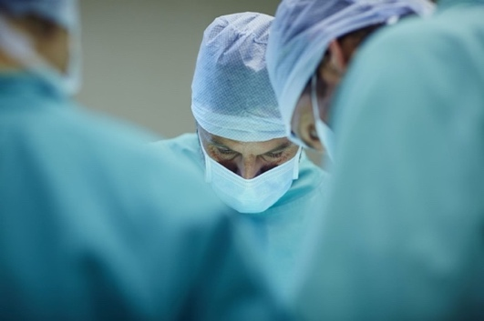

**THE ABAOMS DCT ESSAY PRIZE** is available to all Dental Core Trainees in the United Kingdom with and interest in Oral Surgery and Oral & Maxillofacial Surgery.

This year the prize will be awarded for the best essay (1500-word max) on the following topic:

**“WHAT IS THE IMPACT OF BIOLOGICS ON THE MANAGEMENT OF THE ORAL SURGERY PATIENT?”**

* Conditions of entry and marking criteria can be found on the ABAOMS website <https://abaoms.org/education-committee/>
* **THE WINNER WILL BE INVITED TO PRESENT THEIR ESSAY AS A POSTER AT THE 2023 ABAOMS CONFERENCE AND RECEIVE £100.00 PRIZE. THEY WILL ALSO HAVE THE OPPORTUNITY TO PUBLISH THE ESSAY IN THE ‘ORAL SURGERY’ JOURNAL.**
* **The closing date** for entry will be the **31st of March 2023**.
* You must be an ABAOMS member to be eligible to submit an entry.
* Essays should be submitted through the ABAOMS website. When uploading essays please wait for the upload to complete to ensure entry is complete.
* The winner of the prize winner will be notified by 31st May 2023.

[www.abaoms.org.uk](http://www.abaoms.org.uk)