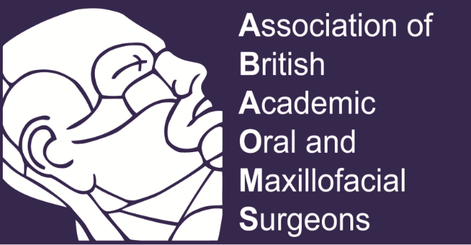

Glasgow, 24-25 November 2022

The conference will be held in the stunning countryside in Scotland,

at The Mar Hall Golf and Spa resort.

CONFERENCE PROGRAMME

Thursday, 24th November

14:00 – 15:00 Trainee committee

Education Committee

ABAOMS Committee

15.00 – 15.20 Coffee

15.25 Welcome (Ashraf Ayoub)

Session 1 Tissue Bioengineering

15.20 – 16.30 Recent advances in tissue bioengineering for maxillofacial reconstruction; from the lab to the patients

Prof M Dalby, Prof M Salmeron-Sanchez, Prof A Ayoub

16.30 – 17:00 Contemporary management of oral Cancer

Mr J McMahon

17:00 – 17.30 Discussion

19:00 Drinks reception

19:30 Dinner at conference hotel

21.30 Scottish music

Friday, 25th November

08:30 – 08:40 Welcome Ashraf Ayoub

Session 2 Dentofacial Deformities Chair: Dr K Naudi

08:45 – 09:30 Recent advances in the diagnosis and management of dentofacial deformities

Mr Philip Benington, Prof A Ayoub

09.30 – 09.40 Discussion

09.40 – 10.10 Domestic Abuse: What Oral Surgeons need to know

Prof C Goodall

10.10 – 10.20 Discussion

10:20 – 11.00 Coffee Break & Trade Exhibition/Poster presentation

11.00 – 12.30 Free Papers Chair: Prof A Bell
(8 minutes presentation, 2 minutes discussion)
11.0 – 11.10 Yuxi Zhu
The facial artery musculo-mucosal (FAMM) flap: a novel island
technique.

11:10 – 11:20 Hanya Mahmood
Prediction of malignant transformation and recurrence of oral epithelial dysplasia using architectural and cytological feature specific prognostic models

11.20 – 11.30 Panagiotis Pitros
The use of Leukocyte-Platelet Rich Fibrin( L-PRF) in bone augmentation.

11:30 – 11.40 Jessica Blanchard
The Use of Augmented Reality in Dental Education and Surgical Planning

11.40 – 11.50 Chloe Bass
An Audit on Head and Neck Cutaneous Basal Cell Carcinoma and Squamous Cell Carcinoma Excision and Completeness of Histopathological reporting

11.50 – 12.00 Hanan Abukhzaam
Development of a custom-made 3D-printed bone substitute for critical-size bone defect repair
12.00 – 12.10 Kasia Gurzawska-Comis
Immune-instructive scaffolds modulating inflammation to promote bone regeneration

12.10 – 12.20 Hamideh Saghafi
The 3D assessment of skeletal stability following orthognathic surgery in surgery-first approach and orthodontic-first approach.

12.20 – 12.30 Daakshini Patel
A two-cycle compliance audit of the WHO Surgical Checklist in Maxillofacial Theatres at Royal Derby Hospital

12.30 – 12.40 Pankaj Taneja
CPR training via virtual reality: A dental student perspective

12:40 – 13:10 Leadership lessons from the Covid-19 response

Prof J Leitch

13:10 – 14:10 Lunch

Session 3 Innovations

14:10 – 14:40 The clinical Application of Dynamic Navigation

Prof A Ayoub

14:40 – 15.00 Robotic Surgery

Prof M Imran

15.00 – 15.15 Discussion

15:15 – 15:45 Coffee Break & Trade Exhibition/Poster presentation

Session 4 Education Chair: Prof A Ayoub

15.45 – 16.05 The challenges of delivering undergraduate education

Prof A Bell

16.05 – 16.25 Longitudinal Assessment vs Summative Assessment, the debate rages on!

Dr K Naudi

16.25 – 16.40 Discussion

16.40 – 17.30 ABAOMS AGM

Poster Presentaions

- Murtaza Hirani
Evaluating adherence to the acceptance criteria for NHS-funded dental implants

- Catriona O’Hare
Assessment of Dental Undergraduates confidence in undertaking minor oral surgery procedures

- Anand Lalli
Evaluation of a Pragmatic Tooth-Marking System for Effective Implementation of Surgical Safety Checklists on Exodontia Teaching Clinics.

- Charlo-e Richards
A systematic review and meta-analysis of the effect of metabolic disorders on the risk of head and neck squamous cell carcinoma.

- Laura Colgan
Virtual Suturing Tutorials

- Omar Ehsan

Oral surgery wait times in NHS secondary dental care in England: a five-year review
- Taha Alibhai
Prevention is better than cure – should all partially erupted impacted mandibular third molars be removed? (ABAOMS undergraduate essay prize winner 2021)

- Soo Sun Chong
Extrapulmonary tuberculosis presenting as bilateral cervical and submandibular lymphadenopathy: A rare case report.

- Emma Robinson
From undergraduates to dentists - transformative learning on oral surgery clinics

- Laura Colgan
Delivering a Local Anaesthetic Symposium virtually

- Emma Beecroft
Developing an in vitroneuronal model of orofacialneuropathic pain

- Julia Palmer
Significant gender differences in the prevalence and chronification of orofacial pain in adolescents

