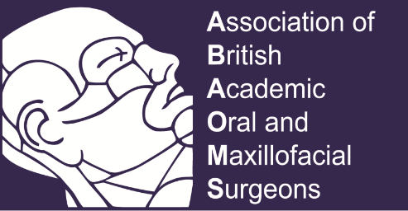

The conference of the ABAOMS will be held in the stunning countryside of Scotland

25th & 26th November 2022

At the Mar Hall Golf & Spa resort

Submission of abstracts
The scientific committee will only assess the provided abstract forms which are submitted before the closing date. Each abstract should not contain more than 300 words, the structure of the abstract should include the following: Background; Aim of the study; Methods; Results; Conclusion.
The abstract will be assessed against the following Five criteria:
1. Is the subject relevant, important, and original?
2. Are the objectives clearly stated?
3. Is the design/methods/programme/approach appropriate?
4. Are the results or outcomes clearly presented?
5. Are the conclusions justifiable and useful?

Abstract Form
Name
Institution
Title
Abstract | Aim:  Methods:  Results:  Conclusions:
Method of presentation | [ ] Verbal [ ] Poster [ ] Any
Please email the completed form to Prof. A Ayoub (Ashraf.ayoub@glasgow.ac.uk)
Deadline: Monday 4th July 2022.

