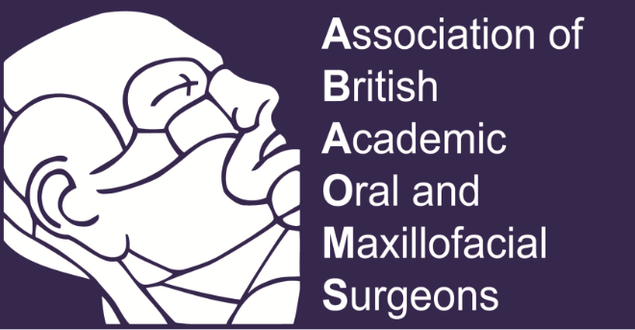
Glasgow, 24-26 November 2022

The conference will be held at the stunning countryside in Scotland, The Mar Hall Golf and Spa resort

CONFERENCE PROGRAMME

Thursday, 25 November

14:00 – 15:00 Trainee Committee meeting

Education Committee meeting

ABAOMS Committee meeting

15.0-15.20 Coffee

Welcome
Ashraf Ayoub

Session 1 Tissue Bioengineering Chair: A Ayoub

15.20 – 16.30 “Recent advances in tissue bioengineering for maxillofacial reconstruction; from the lab to the patients”

Matt Dalby & Manuel Salmeron-Sanchez & Ashraf Ayoub

16.30 – 17:00 “Contemporary management of Oral Cancer”
Jeremy McMahon

17:00– 17.30 Discussion

19:30 Dinner at Conference Hotel

Friday, 26th Nov

08:00 – 08:15 Welcome
Ashraf Ayoub

Session 2 Dentofacial Deformities Chair: Kurt Naudi

09:00 – 09:30 The surgery first approach in Orthognathic Surgery
P. Benington

9.30-10.00 Multidimensional digital imaging and planning in oral & maxillofacial region
A Ayoub

10.00-10.15 Discussion

10:15-10.45 Coffee Break & Trade Exhibition/Poster presentation

10:50– 11:30 Free Papers Chair: Fiona Mackenzie

10.50 – 11:00

11:00 – 11:10

11.10 -11.20

11:20 – 11.30

11.30-11.40

11.40-11.50

11.50-12.00

12.00-12.10

12.10-12.20

12.20-12.30

12:30 – 13:00 Health & Safety; recovering from the Covid-19 pandemic
Jason Leitch

13:00 – 14:00 Lunch

Session 3 Innovations Chair: TBD

14:00 – 14:40 Dynamic Navigation
Mohammed Al Jarsha, Kurt Naudi, Douglas Robertson, Ashraf Ayoub

14:40– 15.00 Robotic Surgery
Muhammed Imran

15.00-15.15 Discussion

15:15 – 15:45 Coffee/poster presentations/trade exhibition

Session 4 Education Chair: TBD

15.45-16.00 The challenges of delivering undergraduate education
Aileen Bell

16.00 – 16.10 Develop (LIFTUPP)
Kurt Naudi / Jamie Dickie

16:10 – 16.30 A vison for the future
Ian McInnes

16.30-16.45 Discussion

16.45-17.30 ABAOMS AGM

